Procedure to Install the UV Ring System on Massivit1800 (new and old electrical cabinet) and 1500 Machines

# Purpose

## Intended audience

Production, engineering, integration, sales & marketing personnel

# Installation Procedure for 1800 Machine (old electrical cabinet)

## Contents of UVR installation kit for the old 1800 electrical cabinet

|  |  |  |  |
| --- | --- | --- | --- |
| Qty | PN | Description |  |
| 1 | ASM-01476A | UVR HEAD | 1 |
| 1 | ASM-01479A | DRIVER | 2 |
| 1 | PRT-01650A | BRACKET UV HEAD ASSY | 3 |
| 3 | SCR-40076 | SCREW SEMS M4X8 | 4 |
| 3 | NUT-001000 | NUT,SLOT,M4,MULTI AXIS,ST | 5 |
| 1 | PRT-30891A | ALIGNMENT TOOL | 6 |
| 1 | MA-01-5257 | CABLE FROM DRIVER TO UVR | 7 |
| 1 | MA-01-5258 | CABLE DRIVER TO BECKHOFF | 8 |
| 1 | MA-01-5259 | CABLE DRIVER TO POWER | 9 |
| 1 |  | 50cm Blake wire 18AWG | 10 |
| 2 | FSD77-8-D | CONN FERRULE DIN 18AWG BLAK | 11 |
| 2 | SJ3550 | 3M Dual lock Re-closable Fastener Black ¾ in X 20cm | 12 |
| 20 | 125X2.5mm | Cable tie | 13 |
| 2 |  | Black air pipe 4mm X 20mm | 14 |

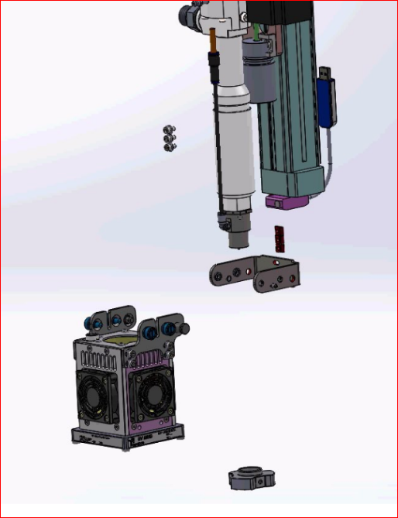

## Installation Procedure

1. Turn off the machine and disconnect the power to it.
2. Disassemble the old UV lamp, including the brackets

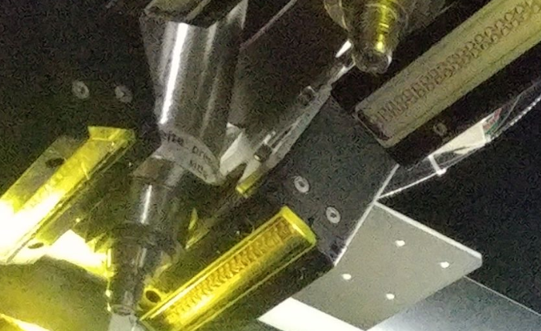

1. Connect the new bracket to the Z-axis using 3 screws (don’t tighten)

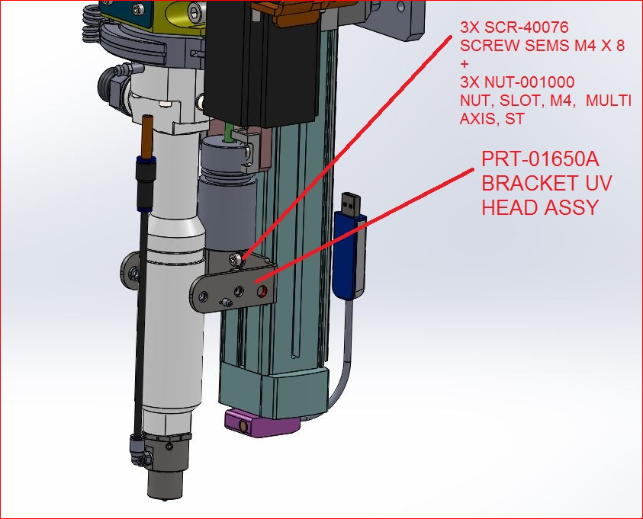

1. Connect the UV lamp to the clamp using 2 pins and 4 screws

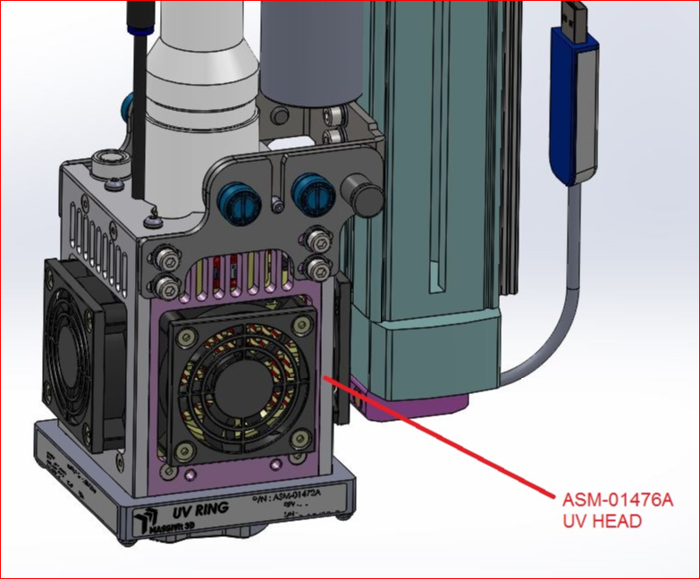

1. Using the jig, adjust the UV lamp to the correct height from the nozzle tip.
2. The correct height is 15 mm from the glass to the bottom of the tip

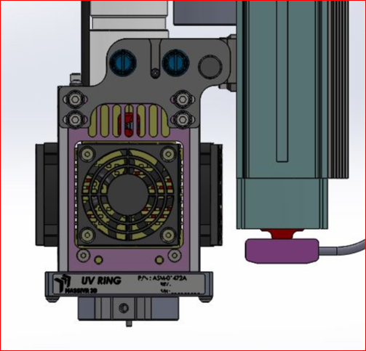

1. Tighten the three (3) bracket screws and eight (8) UVR screws
2. Route the cable (12-wire) through the cable duct until it reaches the electrical cabinet.
3. Connect the round electrical connector to the UV lamp by turning it lightly until the key aligns with the slot, and then pressing the case down.

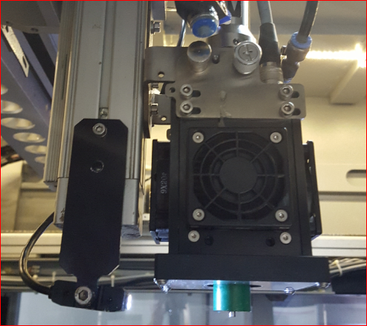

bracket

Round connector

1. Connect the 15-pin D connector to the DRIVER box in the old 1800 electrical cabinet as follows:
2. The DRIVER box is installed in the electrical cabinet near the top covering (on the panel with two fans) using double sided adhesive.
3. Connect the 12-pin D-type connector to the Driver.
4. Route all cables through cable ducts.

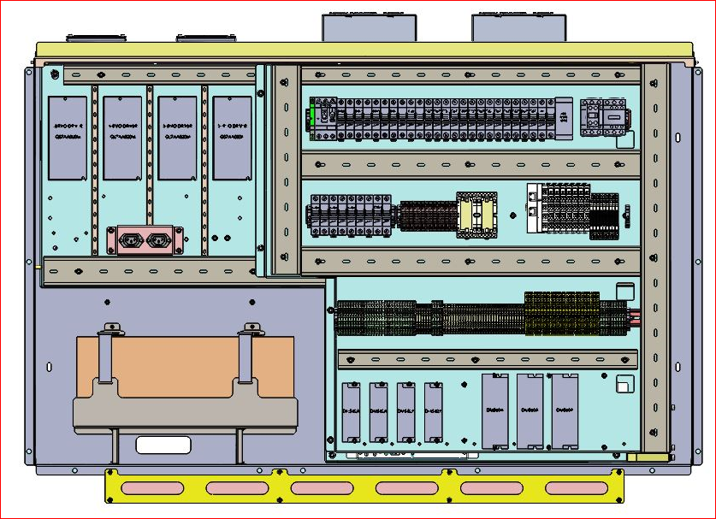

1. Connect the 25-pin cable (MA-01-5258) to the left UV ring DRIVER box, as follows, and route the cable through the ducts:
2. TB A03 and A04 belong to the left head DRIVER box:
3. Connect INTENSITY 1 and INTENSITY 2 to A03
4. Connect INTENSITY 3 and INTENSITY 4 to A04
5. Connect ENABLE 1 and ENABLE 2 to D03
6. Connect ENABLE 3 and ENABLE 4 to D04
7. Connect the 25-pin cable (MA-01-5258) to the main right box as follows:
8. TB A01 and A02 belong to the right head DRIVER box
9. Connect INTENSITY 1 and INTENSITY 2 to A01
10. Connect INTENSITY 3 and INTENSITY 4 to A02
11. Connect ENABLE 1 and ENABLE 2 to D01
12. Connect ENABLE 3 and ENABLE 4 to D02
13. Insulate and tie up the 4 READY wires in each of the MA-01-5258
14. Connect the 4 GND wires in each of the MA-01-5258 cables to -VDC of the 24V supply.
15. Leave the TEMP wire exposed (at end of the installation, insulate it)
16. Connect the power supply to the power connections in the old 1800 cabinet as follows:
17. Connect the power cable MA-01-5259 to the DRIVER box, and pass the cable through the channel towards relay R13
18. Connect the RED wire of the right side UVR driver to pin 24 on relay R13
19. Connect the RED wire of the left side UVR driver to pin 34 on relay R13
20. Insulate the WHITE wire and tie it up
21. Connect the BLACK wire to TB-48
22. Connect the BLACK wire (AWG18) to short between TB 48 and TB 24 (use terminal FSD77-8-D on both sides of the wire).
23. Connect a digital voltmeter between the fasteners, and confirm 48V, and also confirm 48V between pin 24 in relay R13 on the right side and pin 34 in relay R13 on the left side
24. Using a small screw DRIVER, adjust the voltage of the UV unit from 48V to 52V
25. Power supply “PS2” feeds the right head, and “PS1” feeds the left head UV system.

# Installation Procedure for 1800 Machine (new electrical cabinet)

## Contents of UVR installation kit for the new 1800 electrical cabinet

|  |  |  |  |
| --- | --- | --- | --- |
| Qty | PN | Description |  |
| 1 | ASM-01476A | UVR HEAD | 1 |
| 1 | ASM-01479A | DRIVER | 2 |
| 1 | PRT-01650A | BRACKET UV HEAD ASSY | 3 |
| 3 | SCR-40076 | SCREW SEMS M4X8 | 4 |
| 3 | NUT-001000 | NUT,SLOT,M4,MULTI AXIS,ST | 5 |
| 1 | PRT-30891A | ALIGNMENT TOOL | 6 |
| 1 | MA-01-5257 | CABLE FROM DRIVER TO UVR | 7 |
| 1 | MA-01-5258 | CABLE DRIVER TO BECKHOFF | 8 |
| 1 | MA-01-5259 | CABLE DRIVER TO POWER | 9 |
| 1 |  | 50cm Blake wire 18AWG | 10 |
| 2 | FSD77-8-D | CONN FERRULE DIN 18AWG BLAK | 11 |
| 2 | SJ3550 | 3M Dual lock Re-closable Fastener Black ¾ in X 20cm | 12 |
| 20 | 125X2.5mm | Cable tie | 13 |
| 2 |  | Black air pipe 4mm X 20mm | 14 |
| 6 | FSD75-6-D | CONN FERRULE DIN 22AWG WHITE | 15 |



## Installation Procedure

1. Turn off the machine and disconnect the power to it.
2. Disassemble the old UV lamp, including the brackets.



1. Connect the new bracket to the Z-axis using 3 screws (don’t tighten).



1. Connect the UV lamp to the clamp using 2 pins and 4 screws.



1. Using the jig, adjust the UV lamp to the correct height from the nozzle tip.
2. The correct height is 15 mm from the glass to the bottom of the tip.



1. Tighten the three (3) bracket screws and eight (8) UVR screws.
2. Route the cable (12-wire) through the cable duct until it reaches the electrical cabinet.
3. Connect the round electrical connector plug to the UV lamp by turning it lightly until the key aligns with the slot, and then pressing the case down.



bracket

Round connector

1. Connect the 15-pin D connector to the DRIVER box in the new 1800 electrical cabinet as follows:
2. In the electrical cabinet opposite the power panel at the top, approx. 10cm to the right of the MOONS DRIVER, place the DRIVER box (as illustrated in the figure bellow), and affix it to the metal, parallel to the MOONS DRIVER (check that the power supply connector is on top) using double sided adhesive.
3. Connect the 12-pin D-type connector to the Driver.
4. Route all cables through the cable ducts.

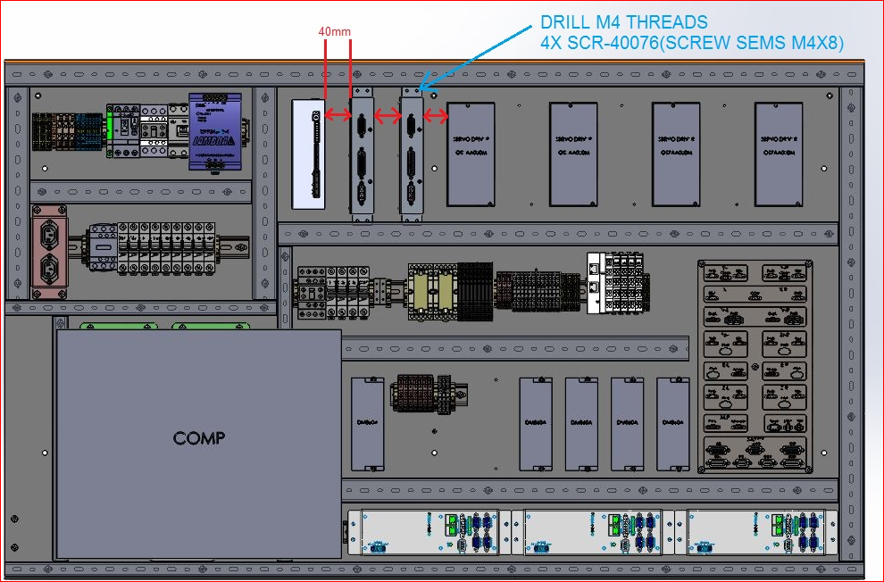

1. Connect the 25-pin cable (MA-01-5258) to left head UV ring DRIVER box, as follows, and lay the cables through the ducts:
2. TB A03 and A04 are in the left box.
3. Crimp INTENSITY 1 and INTENSITY 2 into a single wire terminal (FSD75-6-D) and connect to A03.
4. Crimp INTENSITY 3 and INTENSITY 4 into a single wire terminal (FSD75-6-D) and connect to A04.
5. Crimp ENABLE 1 and ENABLE 2 into a single wire terminal (FSD75-6-D) and connect to D03.
6. Crimp ENABLE 3 and ENABLE 4 Press together to into a single wire terminal (FSD75-6-D) and connect to D04.
7. Connect the 25-pin cable (MA-01-5258) to the right head UV ring DRIVER box, as follows:
8. TB A01 and A02 are in the right box.
9. Crimp INTENSITY 1 and INTENSITY 2 into a single wire terminal (FSD75-6-D) and connect to A01
10. Crimp INTENSITY 3 and INTENSITY 4 into a single wire terminal (FSD75-6-D) and connect to A02.
11. Crimp ENABLE 1 and ENABLE 2 into a single wire terminal (FSD75-6-D) and connect to D01.
12. Crimp ENABLE 3 and ENABLE 4 into a single wire terminal (FSD75-6-D) and connect to D02.
13. Insulate and tie up the 4 READY wires in each of the MA-01-5258 cables.
14. Connect the 4 GND wires in each of the MA-01-5258 to -VDC of the 24V supply.
15. Leave the TEMP wire exposed (at end of the installation, insulate it).
16. Connect the power supply to the power connections in the new 1800 cabinet as follows:
17. Connect the power cable MA-01-5259 to the DRIVER box and pass the cable through the channel towards relay R13.
18. Connect the RED wire of the right-side driver to pin 24 on relay R13.
19. Connect the RED wire of the left side driver to pin 14 on relay R13.
20. Insulate the WHITE wire and tie it up.
21. Connect the BLACK wire to TB-48RTH.
22. Connect the BLACK wire AWG18 to short between TB-48RTH and TB-24 (use terminal FSD77-8-D on two side of the wire).
23. Connect a digital voltmeter between the fasteners, and confirm 48V, and also confirm 48V between pin 24 in relay R13 on the right side and pin 14 in relay R13 on the left side.
24. Using a small screw DRIVER, adjust the voltage of the UV unit from 48V to 52V.
25. Power supply “S.P#48R” feeds the right head, and “S.P#48L” feeds the left head UV ~~ring~~.
26. Verify the installation:
27. Reconnect power to the machine, turn on the computer and start the program. Close the doors and check that the system works correctly.
28. Connect a digital voltmeter between the TEMP wire in cable MA-01-5258 and the -24V or -48V.
29. If the reading is about 4V, indicating room temperature (20-25°), this indicates the system is receiving correct voltages.
30. Close the doors and turn on the UV system to 50%, and check that all the LED lights in the two rings of the UVR are lit.
31. Increase the intensity to 100% and check that the intensity increases.
32. Reduce the intensity to 10% and check that the intensity is reduced to the minimum.
33. Reduce the intensity to 0% and check that all the LED lights are off.
34. If the above steps worked as described, the system is working correctly.
35. Test scanning and the UV intensity using a UV measuring device.
36. This test will help confirm that there are no obstructions that will interfere with printing and that the UV intensity is correct.
37. To check UV in production or service use the Ophir device.
38. To check UV in a Massivit device, use document WI-02-011

# Installation Procedure for 1500 Machine

## Contents of the UVR installation kit for 1500

|  |  |  |  |  |
| --- | --- | --- | --- | --- |
| Qty | PN | | Description | # |
| 1 | ASM-01476A | | UVR HEAD | 1 |
| 1 | ASM-01479A | | DRIVER | 2 |
| 1 | PRT-01650A | | BRACKET UV HEAD ASSY | 3 |
| 4 | SCR-40076 | | SCREW SEMS M4X8 | 4 |
| 6 | FSD75-6-D | | CONN FERRULE DIN 22AWG WHITE | 5 |
| 1 | PRT-30891A | | ALIGNMENT TOOL JIG | 6 |
| 1 | MA-01-5257 | | CABLE DRIVER TO UVR | 7 |
| 1 | MA-01-5258 | | CABLE DRIVER TO BECKHOFF | 8 |
| 1 | MA-01-5259 | | CABLE DRIVER TO POWER | 9 |
| 1 |  | | 50cm Blake wire 18AWG | 10 |
| 1 |  | | CONN FERRULE DIN 18AWG BLAK | 11 |
| 4 | SCR-40076 | | SCREW SEMS M4X8 | 12 |
| 20 | 125X2.5mm | | Cable tie | 13 |
| 1 | PRT-30670A | UVR 1500 Z-PROBE HOLDER | | 14 |
| 4 | SCR-00410 | SOCKT HEAD CAP SCREW DIN912 M4X10 | | 15 |
| 1 | 170781-2 M5 RING LUG | TE CONNECTIVITY 170781-2 Ring terminal M5 | | 16 |
| 2 |  | Black air pipe 4mm X 20mm | | 17 |

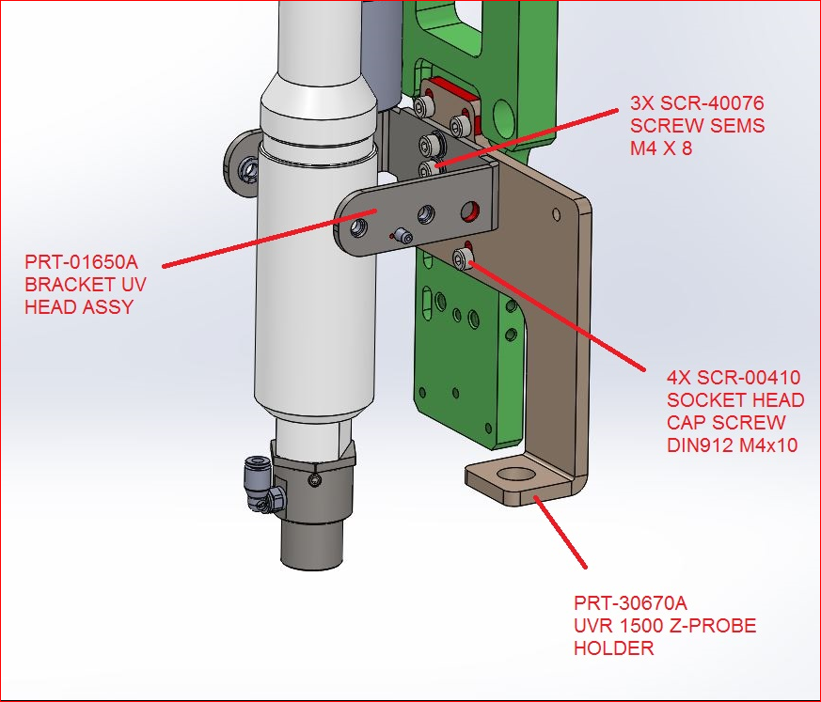

## Installation Procedure

1. Turn off the machine and disconnect the power from it.
2. Disassemble the UV lamp, including the chassis.



1. Connect the new bracket to the small Z-axis using the adaptor that is fastened to the Z-axis by three screws, and the clamp that is fastened by three screws and washers.

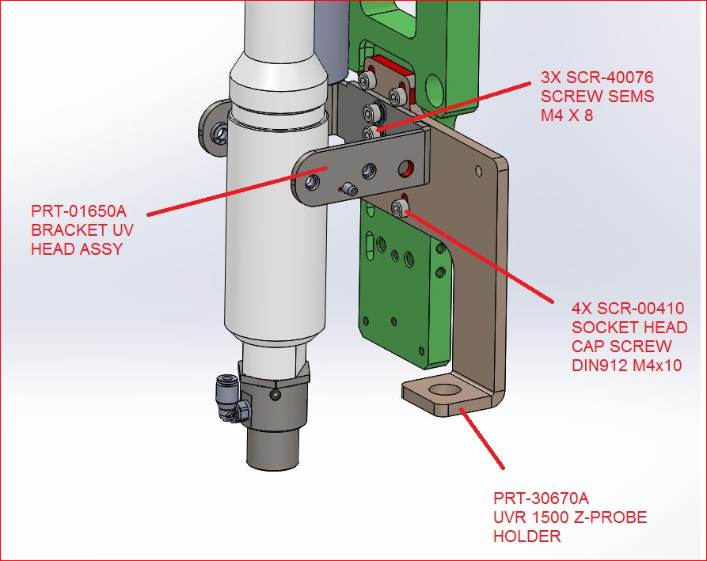

1. Connect the UVR to the clamp using two (2) pins and four (4) fixed screws.

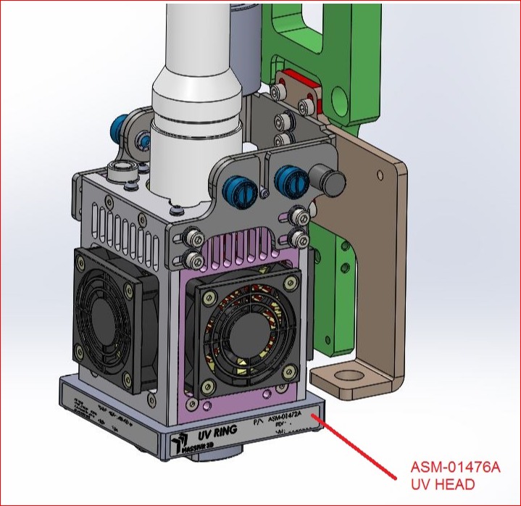

1. Using the jig, move the UVR lamp to the correct height relative to the nozzle tip
2. The correct height is 15mm from the glass to the lower edge of the tip.

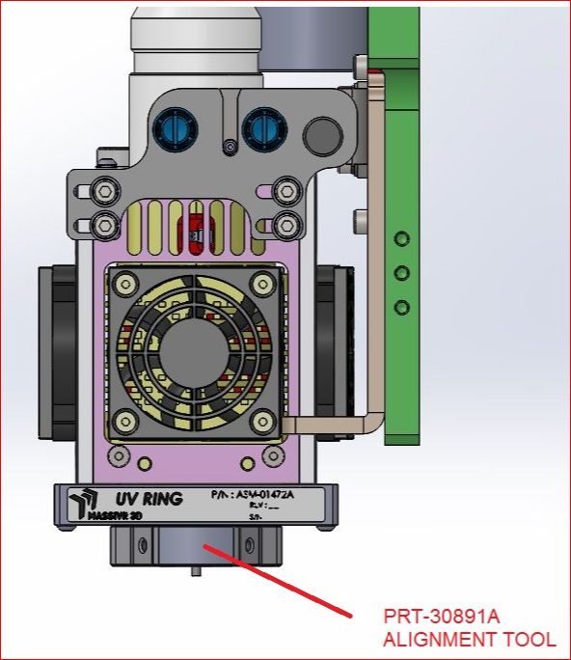

1. Tighten all the screws of the clamp and UVR.
2. Route the 12-wire MA-01-5257 cable through the cable duct until the electrical cabinet.
3. Connect the round electrical connector to the UV lamp by turning it lightly until the connector key slides into the slot, and then pressing the case down.



bracket

Round connector

1. Connect the 15-pin D connector to the DRIVER box in the 1500 electrical cabinet as follows:
2. Install the DRIVER box in the electrical cabinet near the top of the electrical board, on the right side of the connector panel (with the narrow side upwards), and affix it to the electrical board (check that the power connector is on the lower side).
3. Connect the Driver card box with double sided adhesive tape.
4. Connect the 12-pin D-type connector to the DRIVER box
5. Route all the cables through the cable ducts

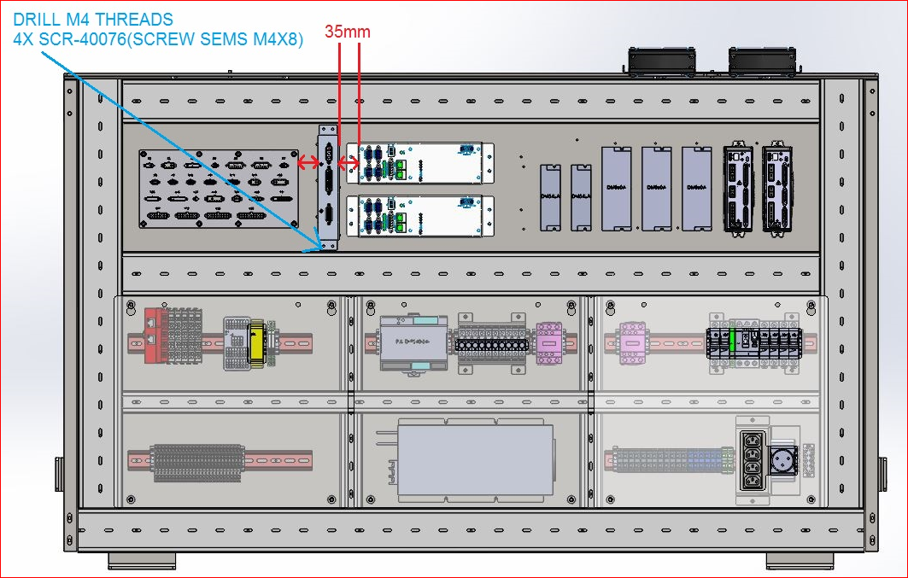

1. Connect the 25-pin cable (MA-01-5258) to the DRIVER box, as follows, and route the cable through the duct to the Beckhoff
2. Press INTENSITY 1 and INTENSITY 2 together to 1 terminal and connect to A01 of the EL4008 unit
3. Press INTENSITY 3 and INTENSITY 4 together to 1 terminal and connect to A05 of the EL4008 unit
4. Press ENABLE 1 and ENABLE 2 together to 1 terminal and connect to t DO6 of the EL2809 unit
5. Press ENABLE 3 and ENABLE 4 together to 1 terminal and connect to DO7 of the EL2809 unit
6. Connect wire READY 1 to port DI1.13 of the EL1809 unit
7. Connect wire READY 2 to port DI1.14 of the EL1809 unit
8. Insulate and tie up the two READY wires in each of the MA-01-5258
9. Leave the TEMP wire exposed
10. Connect the power supply to the power connections of the 1500 electrical cabinet as follows:
11. Connect the power cable MA-01-5259 to the DRIVER box, and pass the cable through the channel towards the fuses (F7)
12. Connect the RED wire to the outgoing pin of fuse F7
13. Insulate the WHITE wire and tie it up
14. Connect the BLACK wire to 48 of the 48V supply
15. Connect the BLACK wire AWG20 to short between 48V output of the 48V power supply and 24V output of the 24V supply
16. Connect a digital voltmeter between the 48V clamps and F7, and check the voltage is 48V
17. Verify the installation:
18. Connect a digital voltmeter between the TEMP wire in cable MA-01-5258 and the -24V or -48V
19. If the reading is about 4V, indicating room temperature (20-25°), this indicates the system is receiving correct voltages.
20. Close the doors and turn on the UV system to 50%, and check that all the LED lights in the two rings of the UVR are lit.
21. Increase the intensity to 100% and check that the intensity increases.
22. Reduce the intensity to 10% and check that the intensity is reduced to the minimum.
23. Reduce the intensity to 0% and check that all the LED lights are off.
24. If the above steps worked as described, the system is working correctly.
25. Test scanning and the UV intensity using a UV measuring device.
26. This test will help confirm that there are no obstructions that will interfere with printing and that the UV intensity is correct.
27. To check UV in production or service use the Ophir device.
28. To check UV in a Massivit device, use document WI-02-011.